Assembling a New Job

Typically, you will work within this area.
START
No

No

No

No

Yes

Yes

Yes

Yes

END
Save
Vision Analysis- Section 5.2.4
Define Feeder- Section 5.2.3
New Part uses Vision Analysis?
Run Assembly- Section 7
Define Place Table- Section 5.2.7
Create New Job- Section 5.2.5
Define Fiducials- Section 5.2.6
New
Feeders?
Create Item- Section 5.2.2
Create Package- Section 5.2.1
New
Package?
New Inventory Items?
Editing and Assembling an Existing Job

Typically, you will work within this area.
Save
Save
Set-up Feeders- Section 11

No

Yes

END
Run Assembly- Section 7
Set -up
Feeders?
No

Edit Place Table- Section 5.2.7
Yes

Open Existing Job- Section 9
START
No

No

No

No

Yes

Yes

Yes

Yes

Vision Analysis- Section 5.2.4
Define Feeder- Section 5.2.3
New Part uses Vision Analysis?
Edit Place
Table?
Realign Fiducials- Section 10
New
Feeders?
Create Item- Section 5.2.2
Create Package- Section 5.2.1
New
Package?
New Inventory Items?

Assembling an Existing Job

Set-up Feeders- Section 11

START
No

Yes

END
Run Assembly- Section 7
Set-up
Feeders
Open Existing Job. Section 9
9.0 - Opening an Existing Job

This section describes the procedure to open an existing job. Even though the system will warn you if you have not saved your current job you should get into the habit of using the File-Save function before you change jobs (unless of course you don’t want to save the file).

- Select File from the top menu line to bring up the File Pull Down Menu as shown in Figure 12.

- Select Open Existing Job from the File Menu (Figure 12). You will now be shown the Open File dialog box as shown below in Figure 13. Select the file you want and then click on the Open button at the bottom of the box.

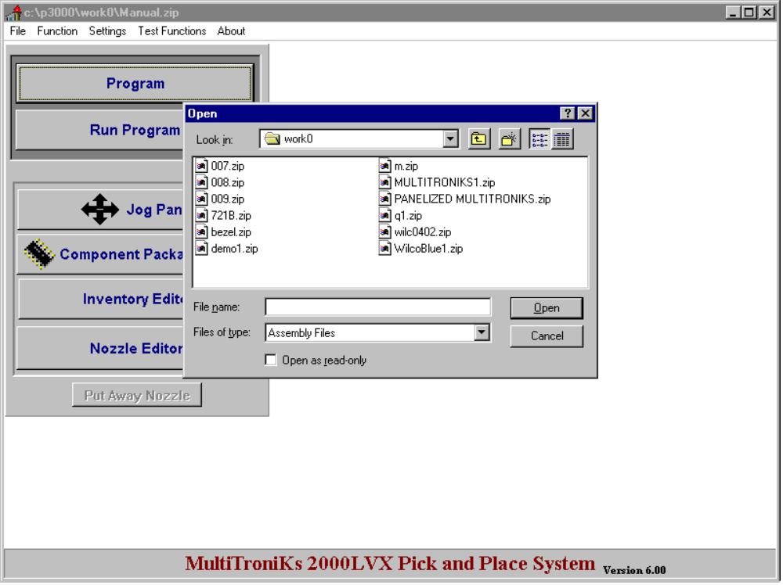

Figure 13

- - Editing an Existing Job

If you need to make changes in a job you must first open the job (refer to section 9.0). You can make changes at will in any of the functions listed below without having to realign the board. Refer to this manual’s Table of Contents to find instructions on programming any of these functions.

- Package Editor (global)
- Inventory Editor (global)
- Job Name
- Job Description
- Vision Analysis (global)
- Error Preferences (global)
- Feeders
- System Settings (global) refer to calibration manual
- limited fields in the Component Placement Editor (see below)

Note: Those items listed as global are not job specific. Any changes in these areas will affect all jobs.

When making changes in the Component Placement Editor, you may change at will the Part Number, the Reference Number, the Angle, and the Description. If you intend to make changes in the component placement coordinates you must first realign the system to the board fiducials. An accurate alignment is very important for accurate placement coordinates.

To realign proceed as follows:

- If you haven’t already done so, open the job you would like to edit and mount your board on the machine.

- From the Main Menu click Program

- From the Program menu click Board Alignment - Fiducial.

- The board alignment window will appear with the Panelized Board Set-up tab active. If you are editing a panelized board click the Realign Panelized Board tab and skip to step nine.

- Using the Jog panel move the camera over Global Fiducial 1 and click Get X,Y. Answer Yes to overwrite data.

- Repeat the following sequence two or three times until the X and Y values stabilize:

- Click on Go Alignment Point
- Click on Get Alignment point
- Click on the Yes button when asked if you wish to overwrite existing data.

- Repeat steps five and six for Global Fiducial 2.

- Go to step fourteen.

- With the Relocate Panelized Board tab selected, make certain panel one is active by click a field within the record one.

- Using the Jog panel move the camera over Global Fiducial 1 of panel one and click Get X,Y. Answer Yes to overwrite data.

- Repeat the following sequence two or three times until the X and Y values stabilize:

- Click on Go Alignment Point
- Click on Get Alignment point
- Click on the Yes button when asked if you wish to overwrite existing data.

- Repeat steps five and six for Global Fiducial 2 for panel one.

- Click Realign Fiducials.

- Close the Board Alignment - Fiducial window.

The system is now ready to have the component coordinates edited.

- - Setting-up Feeders

When you have changed your physical feeder setting between jobs (and even if you haven’t) you may need to reset up your feeders. The following points will need to be checked.

- Reposition the physical tape feeders in their respective slots. To use the software to aid in the set-up of the feeders use the following procedure:
- Click Feeder from the Program menu. Choose a starting position (maybe the front right).
- Click on a block.
- Click a green slot to make it active and then click Move To.
- Get a feeder containing the item listed and, using the camera position as a guide, load the feeder in the slot.
- Update the Counts for that feeder as needed
- Repeat steps three to five for each green slot in the block.
- Close the block and repeat steps two through six for the remaining blocks.

- Stick feeder counts will need to be edited assuming the parts have been used on other jobs. Similar to the tape feeders you can use the software to aid setting the physical feeders up. The difference is moving the camera over the feeder will not allow good access to the vib unit so skip this step.

- Matrix trays have to be positioned in nearly exactly the same position they were programmed. Again use the software to aid in this process but without moving the camera over the tray. If you cannot properly line the tray up for whatever reason, simply align the software to its new position using the Tray Teach feature (see section 5.2.3.2 for help). Available parts in a matrix tray feeder may need to be edited (good, bad, or empty). A quick way to reset a tray is to click the Replace Tray button in the tray editor screen.

12.0 - Panelized Board Set-up

Panels can be setup using one of the two techniques listed below.

- with local fiducial (recommended)
- with offsets

Using local fiducials is a much more reliable method when compared to offsets. In fact, on many boards, this method is necessary for quality placement.

12.1 - Panels Using Local Fiducials

To teach a panelized board using local fiducials, it is recommended that you first teach panel one as if it is a single board (you can even Assembly it alone to check the placement). After you have setup panel one, click Program - Board Alignment from the Main menu. The screen shown in figure 24 will be shown. Notice that panel one’s G1 and G2 coordinates will already be shown in the upper table.

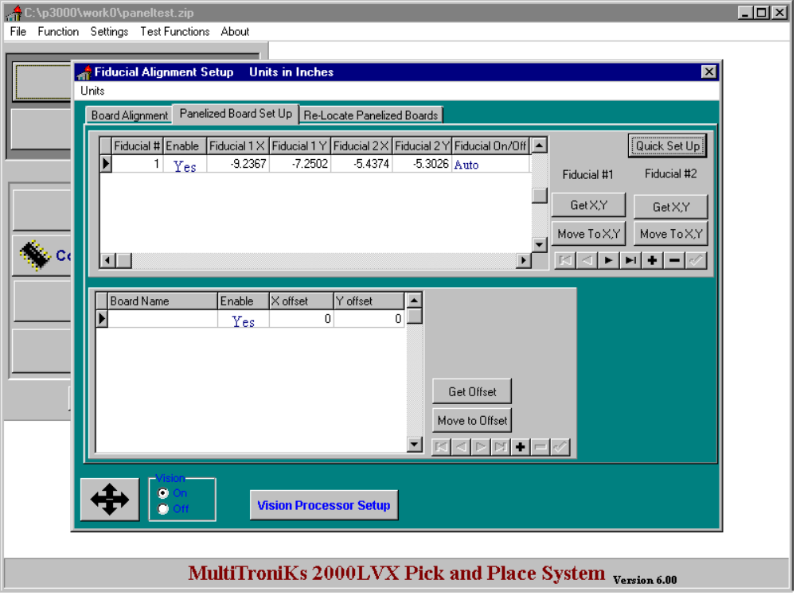

Figure 24

- Click the Quick Setup button to see the screen shown in figure 25.

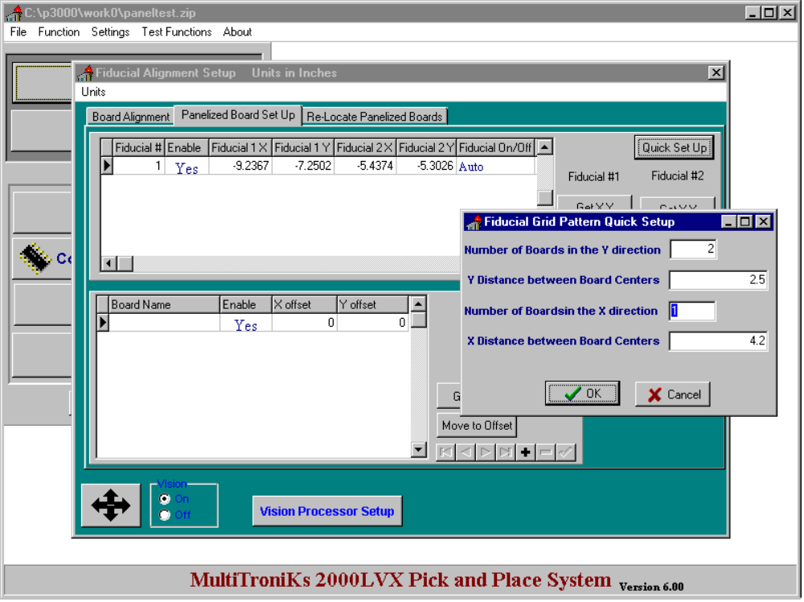

Figure 25

- Fill in the information as needed. The X and Y dimensions do not have to exact but the closer they are to the actual dimensions the easier the next few steps will be.

- Click the OK button to return you to the Panelized Board Setup tab. The computer has now calculated the panel positions based on the information you entered in the quick tray setup.

- Click the First Record button on the navigator bar.

- Click the Next Record button on the navigator bar.

- Click Move To X,Y #1 to move over G1 of the current panel.

- If the fiducial is not entirely inside the box use the Jog Panel to make it so.

Tip: If your offsets in the Quick Setup are off substantially, you may want to adjust them so that you don’t have to use the jog panel to adjust every fiducial. To do this click the First Record button on the navigator bar and then click Quick Setup. Adjust your old X and Y values as needed. Remember that you will have to go back to step four now.

- Click Get X,Y #1

- Click Move To X,Y #2 to move over G2 of the current panel.

- If the fiducial is not entirely inside the box use the Jog Panel to make it so.

- Click Get X,Y #2

- Repeat steps five to eleven for the remaining panels.

12.2 - Panels Using Offsets

Offsets use a pair of global fiducials and a X and Y offset to translate a pattern to each panel. The problem with using this method is that it does not compensate for any angular difference between panels. However, in certain cases, using offsets will work adequately. To set up offsets, begin by teaching the board alignment points and fiducial points. Then proceed as follows:

- From the Main menu, click Program and then Board Alignment. The screen shown in figure 26 will be shown. Notice that G1 and G2 coordinates will be shown in the upper table. The lower table (the offset table) will be blank.

- Using the Jog Panel move over a reference point (any point of your choice that you can replicate on all panels) on panel one.

- Click the Add button on the offset table’s navigator board.

- Click in the Board Name field of the active record and enter a short name like ‘P1’ for panel 1.

- Click the Get Offset button.

- Using the Jog Panel move over the reference point on the next panel.

- Click the Add button on the offset table’s navigator board.

- Click in the Board Name field of the active record and enter a short name like ‘P2’ or ‘P3’, etc..

- Click the Get Offset button.

- Repeat steps six through nine for each of the other panels.

- Click the First Record button on the navigator bar to return to panel one.

- Close the Panelized Board Setup window and proceed to program the board with components (see section 5.2.7). Be careful to program panel one only.

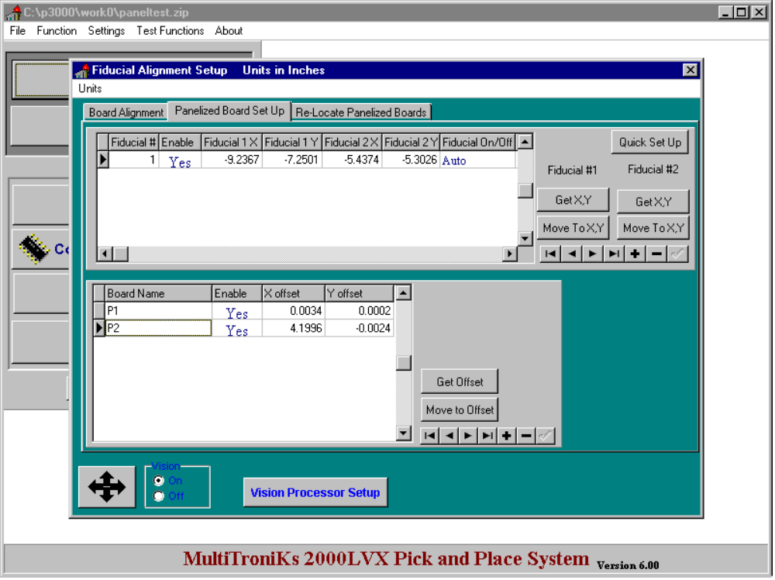

Figure 26

